|  |
| --- |
| Flux of Souls |
| COMP231 – Computer Programmer project |
| test |

11/6/2013

Contents

Project Summary 2

Project introduction 3

Project Minutes 4

High Concept Documentation 5

High Concept 5

Features 5

Player Motivation 5

Genre 5

Target Customer 5

Competition 5

Unique Selling Points 5

Target Hardware 5

Design Goals 6

Characters 6

Project Diagrams and Images 7

Use Case 7

Class Diagram 8

Initial concept GUI 9

# Project Summary

Flux of Souls intro

# Project introduction

Intro

# Project Minutes

Times/details

# High Concept Documentation

**Flux of Souls**

Written by Rudy Caliph

## High Concept

Flux of Souls is turn based strategy game that gives the role of god to the user. The game is a top down view of a map that the players influence souls and fight of bad ones to grow the world and get the highest score possible at the end.

## Features

* World Creation and Manipulation.
* Soul Conversion for point scoring.
* Building system.
* Soul influence.
* Three modes in final and one in prototype.

## Player Motivation

As this world new god you must nurture the world and make it strive to get the best possible souls to get a high score.

## Genre

Turn based strategy game.

## Target Customer

Customers ages 14-30 strategy players.

## Competition

PC Indie strategy games.

## Unique Selling Points

* World Manipulation
* Map style game.
* A.I

## Target Hardware

PC Steam platform and Origin

## Design Goals

**Simple:** The game will be all mouse controlled and the simple user interface will make it easy to pick up for any experienced strategy game player.

**Deep:** With the good and bad A.I will make it different each time for the player and make repeat play fresh.

# Project Diagrams and Images

## Use Case

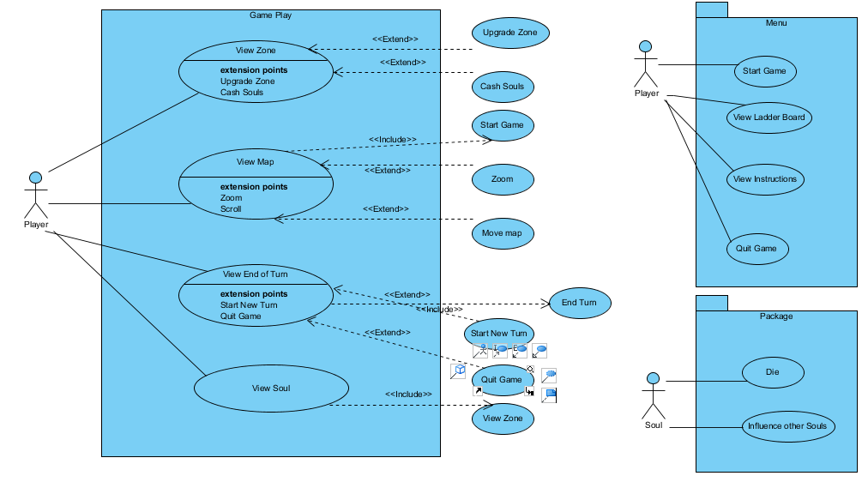

Figure 1.0

## Class Diagram



Figure 1.1

## Initial concept GUI

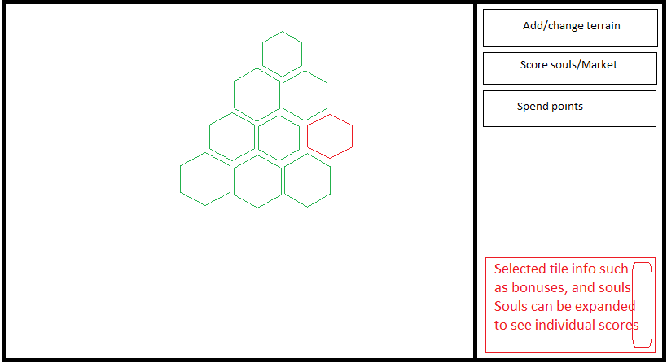

Figure 1.2